Role description | Picture
Social media Volunteer  Share Stories. Spark Change.  Help local families by boosting our online presence and spreading positivity in the community. As a Social Media Volunteer, you’ll create and share engaging posts, promote our events, fundraising and volunteering opportunities, and help grow awareness of the support we offer. We’re looking for someone creative, a confident communicator, and passionate about helping families with a willingness to learn and try new ideas. In return, you’ll gain valuable marketing experience, develop new digital skills, and build your confidence with training and support along the way.  Join us and help make a difference online and beyond. | 
Admin Volunteer  Support Behind the Scenes. Make a Real Difference.  Help our friendly team keep everything running smoothly so we can support even more local families. As an Admin Volunteer, you’ll prepare group and training resources, assist with event and activity administration, and help with photocopying, laminating, and general office tasks. You’ll also provide valuable support to our coordinators and wider team. We’re looking for someone organised, reliable and friendly, with good communication skills and a passion for helping families thrive. In return, you’ll gain hands-on office and admin experience, build new skills and confidence, and receive training and travel expenses. Flexible hours, based in Arnold. | 
Translator Volunteer  Bridge Languages. Build Connections.  Help local families feel heard and understood by supporting communication between staff and families where English isn’t their first language. As a Volunteer Interpreter for our Family mentor service, you’ll assist with conversations at meetings or home visits and help promote inclusion and respect across cultures.  We’re looking for volunteers who are fluent in English and at least one other language, with good communication skills, empathy, and reliability. Volunteers join our interpreter pool and are contacted when language needs arise, so opportunities will vary depending on demand.  In return, you’ll gain valuable experience, develop your skills, and receive training, supervision, and travel expenses. Flexible, meaningful volunteering that makes a real difference. | 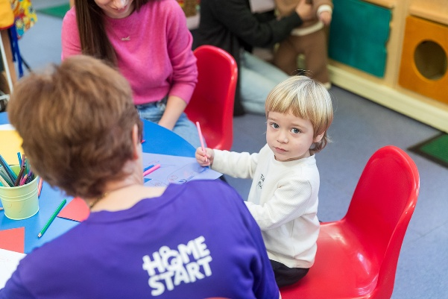
Story Time and Rhyme Group Volunteer  Support Families. Build Community.  Help families feel confident, connected, and included in our group sessions across Nottingham and surrounding areas. Volunteers welcome families, support activities and children’s play, assist parents, and represent Home-Start at community events.  We’re looking for caring, reliable volunteers with good communication, a team spirit, creativity, and a non-judgmental approach.  In return, you’ll make a real difference, gain experience with children and families, build confidence and skills, and meet new people. Training and travel costs are covered.  Group sessions:  - Tuesday 10:30–11:30 – Hyson Green, Marry Potter Centre  - Wednesday 9:45–11:15 – Aspley, Strelley Road Library  - Wednesday 12:30–1:30 – St Ann’s, Valley Library  - Thursday 10:30–11:30 – Clifton Library | 
Event Volunteer  Bring Events to Life. Spread the Word.  Help raise awareness, support families, and promote volunteering by bringing energy and organisation to our events. Volunteers assist with setting up, running, and packing down stalls, create a welcoming atmosphere, answer questions, and help promote Home-Start Nottingham online and in the community.  We’re looking for friendly, organised volunteers with excellent communication and teamwork skills, and a passion for supporting families.  In return, you’ll gain hands-on experience in events and promotion, build skills and confidence, meet new people, and have travel costs reimbursed. Flexible, ad-hoc hours to fit your schedule. | 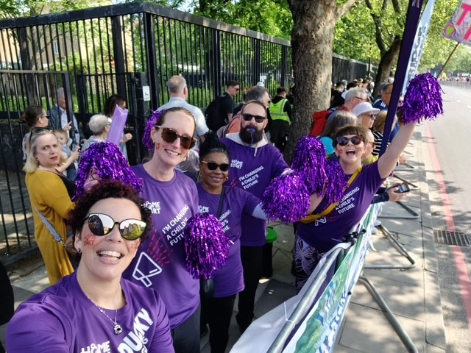
Fundraising Volunteer  Raise Funds. Change Lives.  Support local families by helping plan, promote, and run fundraising activities and events. Volunteers represent Home-Start at community events, assist with planning and running activities, engage local businesses and groups, and promote events online and in the community.  We’re looking for enthusiastic, organised volunteers with creativity, good communication, and a caring attitude. Reliability and teamwork are essential.  In return, you’ll gain experience in fundraising and community engagement, develop skills in event planning, communication, and networking, and receive training, confidence-building, and travel reimbursement. | 
Trustee Volunteer  Help Shape Our Future. Make a Lasting Impact.  Join the board and help guide Home-Start Nottingham in delivering vital support to local families. As a trustee, you’ll contribute your skills and experience to ensure the charity is well-run, financially stable, and compliant, while safeguarding its values and resources.  We’re looking for committed individuals who can attend board meetings, actively contribute ideas, work collaboratively, and uphold high standards of integrity and governance.  In return, you’ll have the opportunity to make a real difference for families, receive support and training, and work alongside a dedicated team of staff, volunteers, and trustees. | 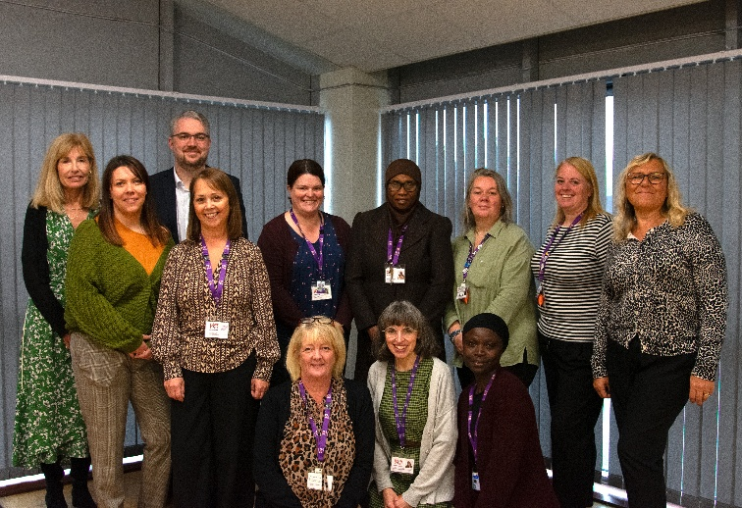
Home Visiting Volunteer  Support Families. Make a Real Difference.  Become a Home-Start Home Visiting Volunteer and help families grow in confidence, enjoy time with their children, and connect with their communities. You’ll offer regular friendship, practical support, and reassurance in the family home, listening, encouraging, and helping parents develop their strengths and emotional well-being. You’ll also guide families to local services, support them to widen their social networks, and provide a consistent, trusted presence during challenging times.  We ask volunteers to complete Home-Start preparation training (group, 1:1, or online), commit to visiting a family weekly for around 2 hours (minimum 1 year), attend ongoing supervision, and approach the role with care, reliability, and non-judgment. Volunteers respect confidentiality, embrace diversity, and bring a positive attitude (and a sense of humour!).  In return, you’ll receive regular guidance and supervision from your coordinator, join volunteer support groups and social events, access ongoing training opportunities, have travel costs reimbursed, and make a lasting, meaningful difference to families’ lives. | 

